**Test Cases:**

For reference this is the initial list:

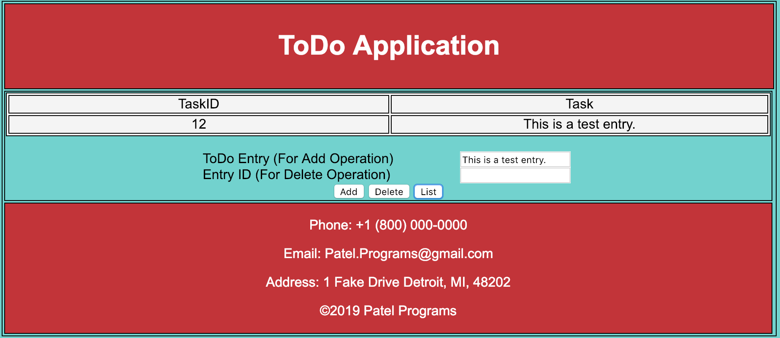

1. Adding “Drop any classes before 1/18.”
   1. Screen shot of inputed text:

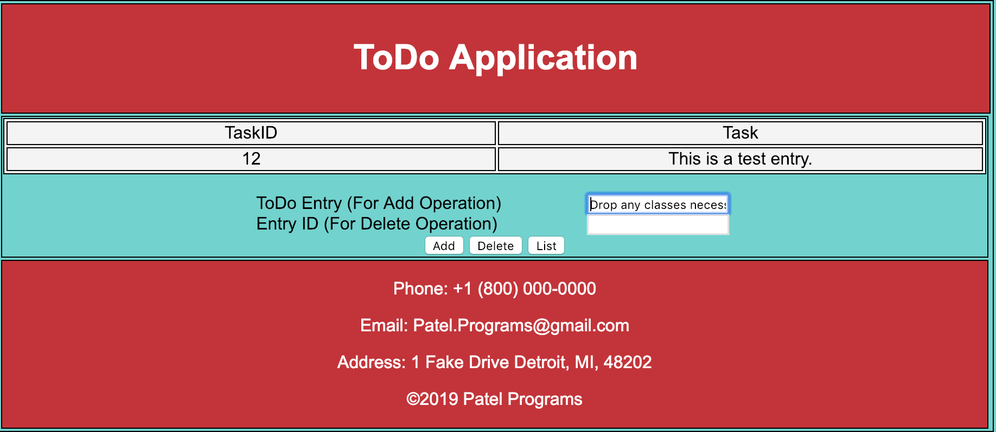

* 1. After Clicking add: 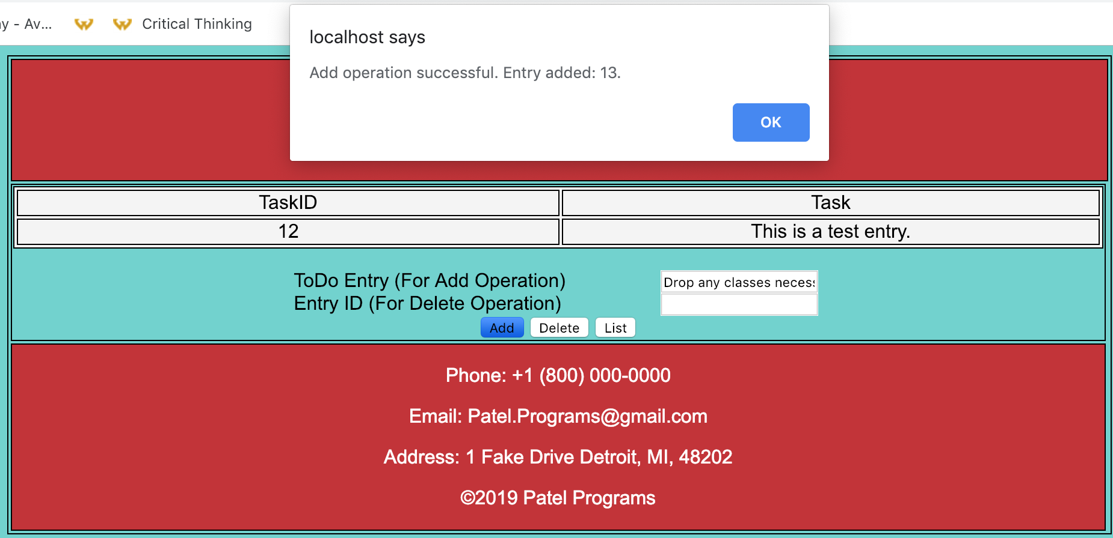

1. List Entry after adding the task above:
   1. Before Clicking list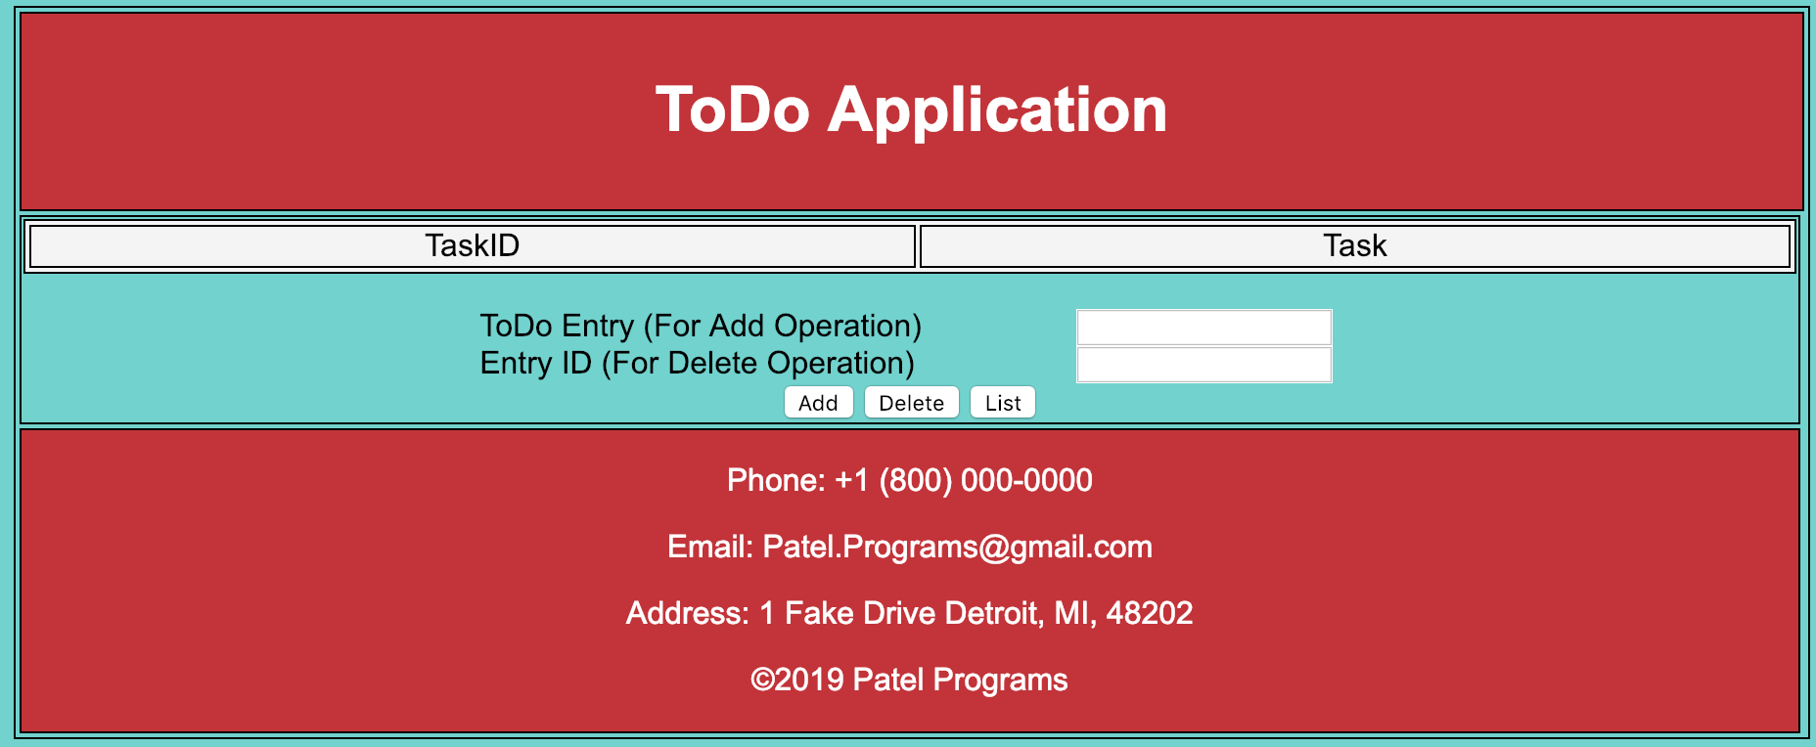
   2. After Clicking List: 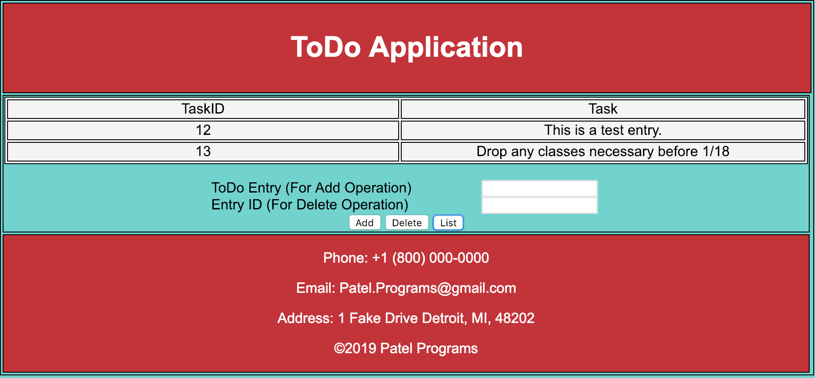
2. After Deleting Task with ID of 12:
   1. After clicking delete: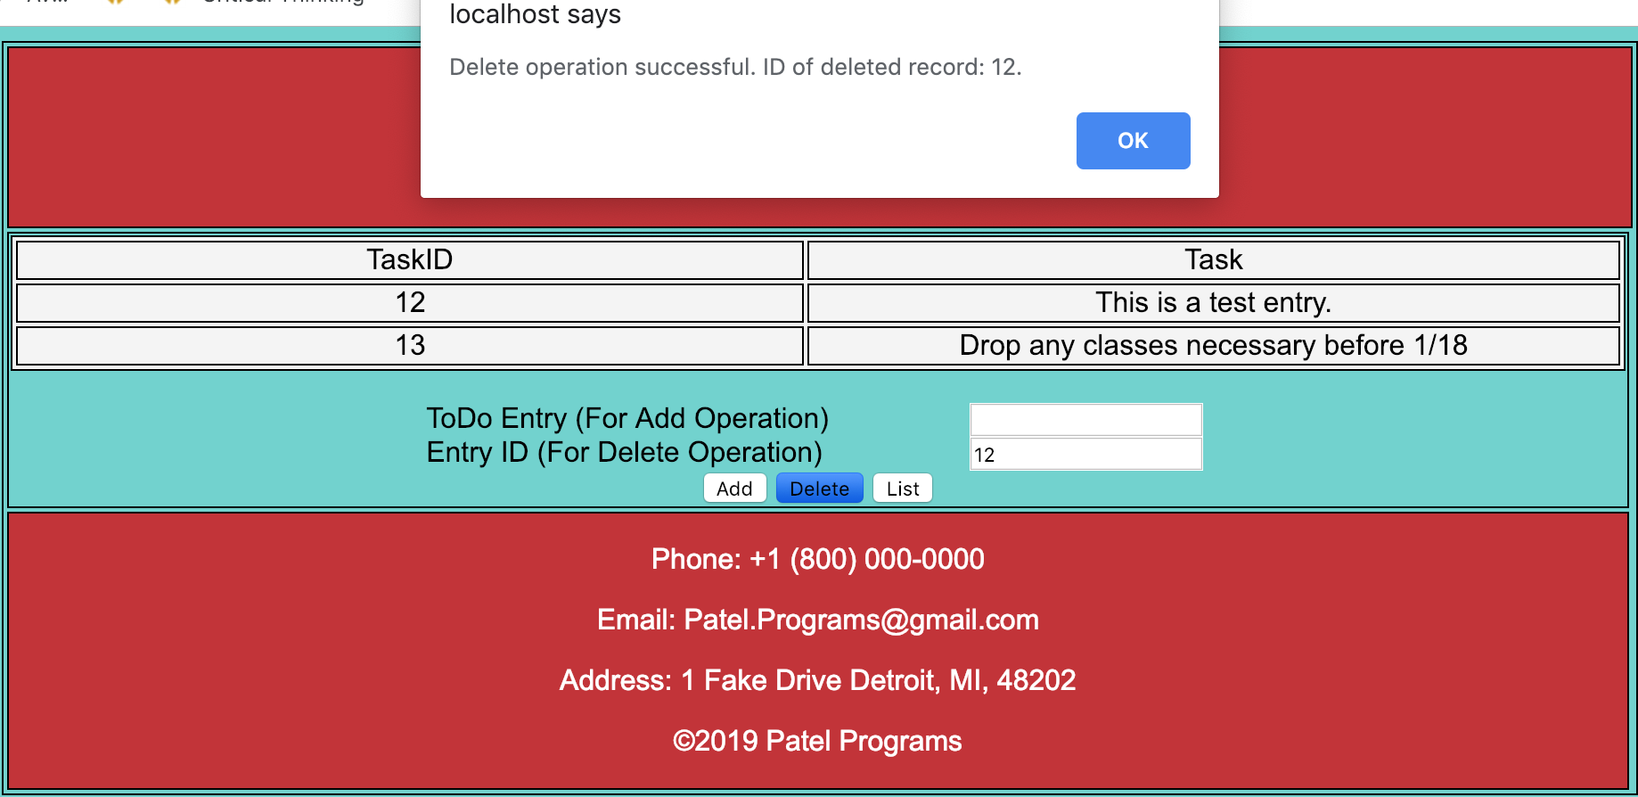
   2. After delete and clicking list: 